Algebra Mathematician:______________________
Quiz 2.1-2.3
Graph the following equations: (Hint: Get the second equation into y = mx + b first)
1. y = $2x-3$ (2 pts) 2. y = $-\frac{3}{2}x+1$ (3 pts)

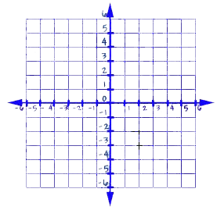

Find the slope between the ordered pairs. (2 pts each)
3. (10, -7) (8, -4) 4. (1, -2) (3, 6) 5. (2, 3) (1, -5)

Put the following equations into slope intercept form, then identify the slope and y intercept.
6. 2y - 6x = 18 (4 pts) 7. 5x + 3y = -3 (4 pts)

Slope: ________ Slope: ________
Y-Intercept: _______ Y-Intercept: _______

Find the slope to write an equation in slope-intercept form. (3 pts each)
8. (7, 4) (8, -1) 9. (-4, 0) (2, 3)

Given the following, find the equation of a line in slope-intercept form.
10. $m=-2$ , b = 10 (1 pt) 11. $m=\frac{1}{2}$ (8, 9) (3 pts) 12. (1, -2) (4, 7) (4 pts)

Extra Credit (MUST TRY IT!)
Write the equation of the line. Also state the slope of the line. (1 point each answer)
13) 14)

Slope of line: _________________ Slope of line: _________________

Equation of line: _________________ Equation of line: _________________

